BMS_ISO Fault

Author: Daniel
Reviewer：Eason

FAQ/BAT
Issue introduction
The inverter reports a BMS_ISO fault and BMS_Selfcheck after connecting to the battery.
Confirmation of basic information
[Photo]SN number of the inverter and the battery.
Guidance for installer
Step1: If the inverter stops reporting the fault after disconnecting the battery from the inverter, follow these steps to troubleshoot whether the issue lies with the BMS or the battery.

Step2: For T30, Disconnect the BMS from the battery and measure the resistance of the BMS. Measure the resistance between B+ and the PE, and between B- and the PE.

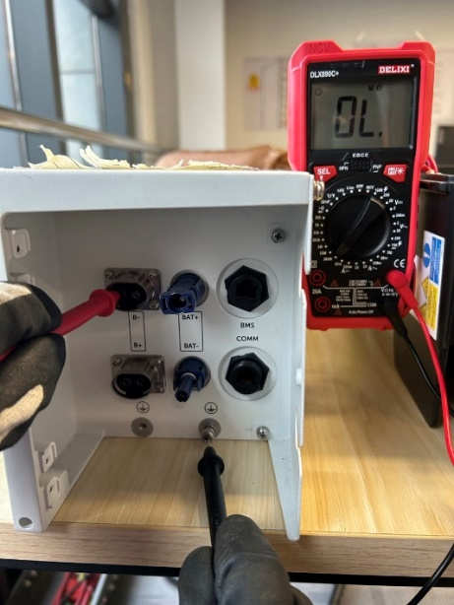 | 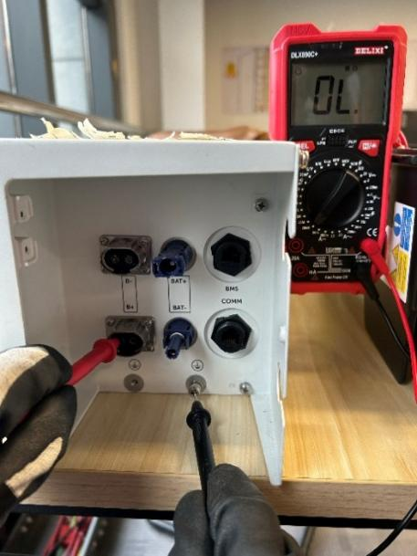
The normal measurement result should be very large, exceeding the range. If the measured value is relatively low, replace the T30 BMS.For T58, try replacing the master battery.

Step3: If the error persists after the above steps, check for insulation issues within the battery.
Connect each slave battery one by one to the master battery, then connect to the inverter to identify the slave battery that is causing the fault. Measure the slave battery voltage between B+ and the PE, and between B- and the PE.
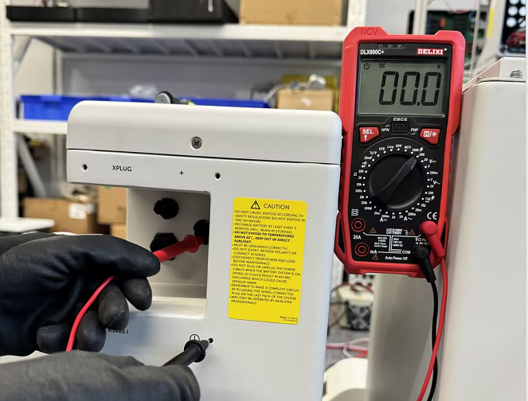 | 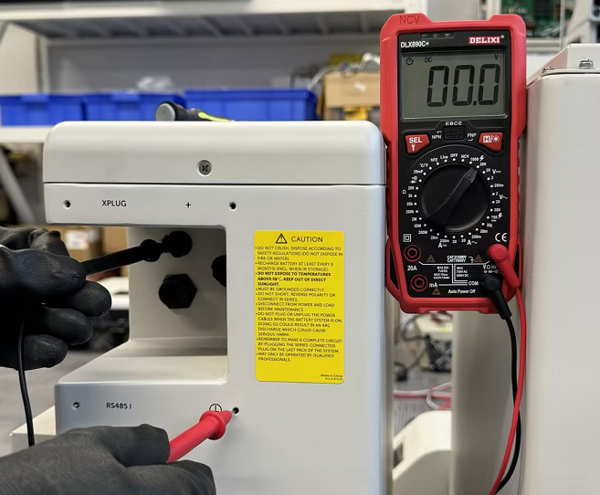
The normal measurement result should be 0. If voltage is detected, it indicates an insulation issue with the battery. Remove it from the system to ensure the other batteries function properly.
Information check list
If you have completed the above <Guidance for installer>, and the problem is still not solved, please collect the following troubleshooting information and send them to the R&D.
1.[Photo] SN number of the inverter and the battery.
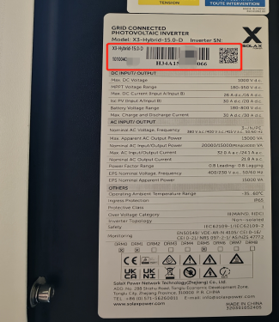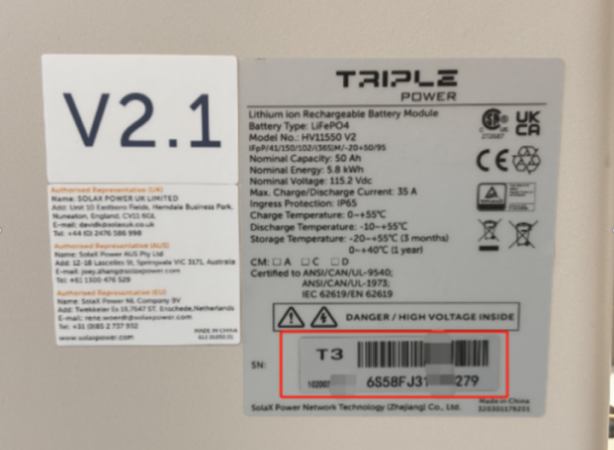
- [Photo]BMS resistance between B+ and the PE,B- and the PE.
 | 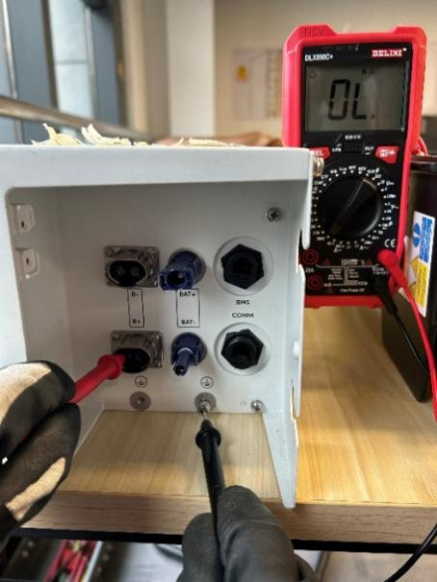

- [Photo] slave battery voltage between B+ and the PE, and between B- and the PE.
 | 

